Lab 7
Binary Tree

Objective:
The objective of this experiment is to build a binary tree and then implement the basic binary tree traversals recursively.

Introduction:
A binary tree is a finite set of nodes that is either empty or consists of a root and two disjoint binary trees called the left subtree and the right subtree.

Array representation of a binary tree:
If a complete binary tree with n nodes is represented using an array, then for any node with index i, 1 ≤ i ≤ n, we have
  - parent(i) is at ⎣i /2⎦ if i ≠ 1.
If i = 1, i is at the root and has no parent.
  - LeftChild(i) is at 2i if 2i ≤ n.
If 2i > n, then i has no left child.
  - RightChild(i) is at 2i+1 if 2i+1 ≤ n.
If 2i +1 > n, then i has no right child

For example the array below represents the following tree:
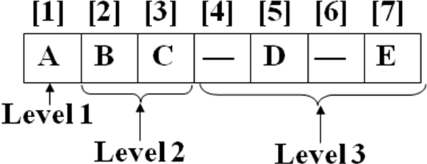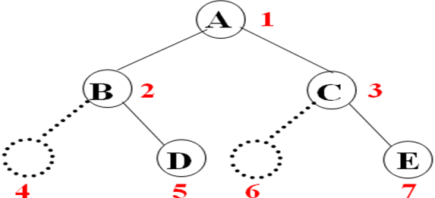

Binary tree traversals:
Since a binary tree is a non-linear data structure, the problem is how to traverse it so we visit each node exactly once. Following are the three basic traversal methodologies in which we traverse the left sub tree before the right sub tree.
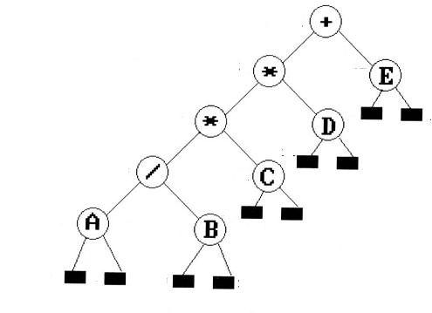

Preorder traversal: To traverse a binary tree in Preorder (VLR) manner following operations are carried-out (i) Visit the root, (ii) Traverse the left subtree, and (iii) Traverse the right subtree.
Therefore, the Preorder traversal of the above tree will output: +**/ABCDE

Inorder traversal: To traverse a binary tree in Inorder (LVR), following operations are carried-out (i) Traverse the left subtree (ii) Visit the root, and (iii) Traverse the right subtree .
Therefore, the Inorder traversal of the above tree will output: A/B*C*D+E
Postorder traversal: To traverse a binary tree in Postorder (LRV), following operations are carried-out (i) Traverse all the leftsubtree (ii) Traverse the right subtree and (iii) Visit the root.
Therefore, the Postorder traversal of the above tree will output:AB/C*D*E+

Exercise 1: Implement the Binary tree node class and part1 and part 2 of the Binary tree class definition given in the header file (name it as BinaryTree.h) below:
#ifndef BINARYTREE_H
#define BINARYTREE_H
template<class DT>
class BNode
{
public:
BNode();
void setLeftChild(BNode<DT>* n);
BNode<DT>* getLeftChild();
void setRightChild(BNode<DT>* n);
BNode<DT>* getRightChild();
void setData(DT pdate);
DT getData();
private:
DT data;
BNode* leftchild;
BNode* rightchild;
};
template<class DT>
class BinaryTree
{
public:
//part1: constructor
BinaryTree ();
//part 2:
//Build the binary tree from the data given in the array.
//If a node doesn't exist the array element is 0
void BuildTree(DT *Arr, int Size);
//part3: post order traversal (recursive)
//you may call any other function with parameters which might be needed
void PostOrder();
//part4: pre order traversal (recursive)
// you may call any other function with parameters which might be needed
void PreOrder();
//part5: in order traversal (recursive)
// you may call any other function with parameters which might be needed
void InOrder();

// part6: prints the height of the binary tree, you may pass any parameters needed
int calculateDepth();

private:
// you may add any other private members which might be needed by recursive functions
BNode<DT>* root;

};
#endif

You may test your code using the client program given below:
//Following is a sample client
#include<iostream>
#include "BinaryTree.h"
#include "BinaryTree.cpp"
using namespace std;
int main()
{
//creating an object of binary tree
BinaryTree<int> *BT=new BinaryTree<int>();

//array to pass, 0 means no node exists
int Arr[15]={0,1,2,3,4,5,6,7,8,9,10,0,12,13,14};

BT->BuildTree(Arr,15); //building the tree from the array
cout<<"***************************************************"<<endl;

return 0;
}

Exercise 2:
Implement part3, part4 and part5 of the header file given in exercise 1. Please test it using the following client
//Following is a sample client
#include<iostream>
#include "Binarytree.h"
using namespace std;
int main()
{
//creating an object of binary tree
BinaryTree<int> *BT=new BinaryTree<int>();

//array to pass, 0 means no node exists
int Arr[15]={0,1,2,3,4,5,6,7,8,9,10,0,12,13,14};

BT->BuildTree(Arr,15); //building the tree from the array
cout<<"***************************************************"<<endl;

cout<<"Preorder Traversal(Recursive) is: "<<endl;
BT->PreOrder();
cout<<"***************************************************"<<endl;
cout<<"Post order Traversal(Recursive) is: "<<endl;
BT->PostOrder();
cout<<"***************************************************"<<endl;
cout<<"Inorder Traversal(Recursive) is: "<<endl;
BT->InOrder();
cout<<"***************************************************"<<endl;

return 0;
}

POST LAB:
Implement part6 of the header file given in exercise 1 that should calculate and print the height of the Binary tree recursively. Please test it using the following client

//Following is a sample client
#include<iostream>
#include "BinaryTree.h"
#include "BinaryTree.cpp"
using namespace std;
int main()
{
//creating an object of binary tree
BinaryTree<int> *BT=new BinaryTree<int>();

//array to pass, 0 means no node exists
int Arr[15]={0,1,2,3,4,5,6,7,8,9,10,0,12,13,14};

BT->BuildTree(Arr,15); //building the tree from the array
cout<<"***************************************************"<<endl;

cout<<"Height of the Binary Tree is: "<<endl;
BT-> calculateDepth();
cout<<"***************************************************"<<endl;

return 0;
}

